**Tensor Flow**

**Day 2:**

I created a database using firebase as follows:

1.First go to firebase.

2.Click on Go to Console

3.Then start a new project, then we have to click on Data Base.

4.Then we get as follows:

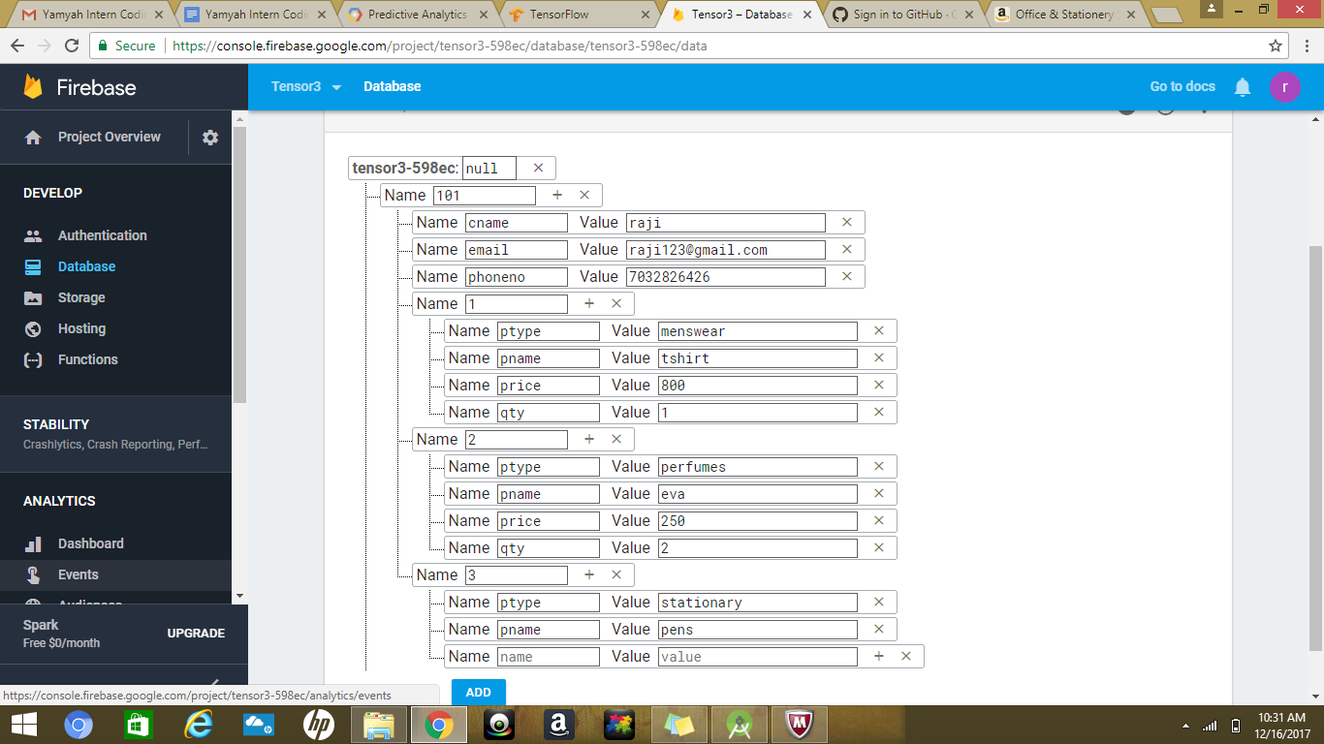

5. Then click on add we have as follows:

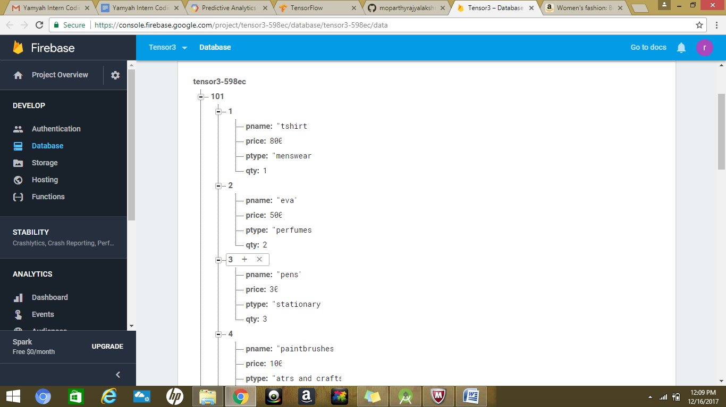

The above table data is present in the link: https://console.firebase.google.com/project/tensor3-598ec/database/tensor3-598ec/data